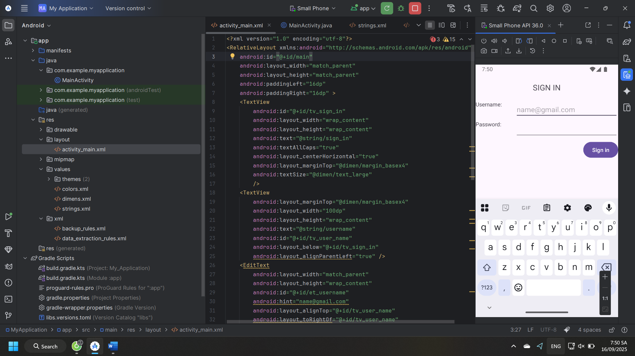Ảnh có chứa văn bản, ảnh chụp màn hình, phần mềm, Phần mềm đa phương tiện

Nội dung do AI tạo ra có thể không chính xác.

<?xml version="1.0" encoding="utf-8"?>  
<LinearLayout xmlns:android="http://schemas.android.com/apk/res/android"  
 android:id="@+id/main"  
 android:layout_width="match_parent"  
 android:layout_height="match_parent"  
 android:orientation="vertical"  
 android:padding="24dp"  
 android:gravity="center_horizontal"  
 android:background="#EEEEEE">  
  
 <TextView  
 android:id="@+id/tv_sign_in"  
 android:layout_width="wrap_content"  
 android:layout_height="wrap_content"  
 android:text="SIGN IN"  
 android:textAllCaps="true"  
 android:textStyle="bold"  
 android:textSize="22sp"  
 android:layout_marginBottom="24dp"/>  
  
 <!-- Username -->  
 <TextView  
 android:layout_width="match_parent"  
 android:layout_height="wrap_content"  
 android:text="Username:"  
 android:layout_marginTop="8dp"/>  
  
 <EditText  
 android:id="@+id/et_username"  
 android:layout_width="match_parent"  
 android:layout_height="wrap_content"  
 android:hint="name@gmail.com"  
 android:inputType="textEmailAddress"/>  
  
 <!-- Password -->  
 <TextView  
 android:layout_width="match_parent"  
 android:layout_height="wrap_content"  
 android:text="Password:"  
 android:layout_marginTop="16dp"/>  
  
 <EditText  
 android:id="@+id/et_password"  
 android:layout_width="match_parent"  
 android:layout_height="wrap_content"  
 android:inputType="textPassword"  
 android:hint="******"/>  
  
 <Button  
 android:id="@+id/btn_sign_in"  
 android:layout_width="wrap_content"  
 android:layout_height="wrap_content"  
 android:text="SIGN IN"  
 android:layout_gravity="end"  
 android:layout_marginTop="16dp"/>  
  
 <!-- Nút phụ giống ảnh mẫu -->  
 <Button  
 android:id="@+id/btn_fb"  
 android:layout_width="match_parent"  
 android:layout_height="wrap_content"  
 android:text="SIGN IN VIA FACEBOOK"  
 android:enabled="false"  
 android:layout_marginTop="24dp"/>  
  
 <Button  
 android:id="@+id/btn_sign_up"  
 android:layout_width="match_parent"  
 android:layout_height="wrap_content"  
 android:text="SIGN UP"  
 android:enabled="true"  
 android:layout_marginTop="12dp"/>  
  
</LinearLayout>

Làm lại bài 2 bằng ContraintLayout

Ảnh có chứa văn bản, phần mềm, ảnh chụp màn hình, máy tính

Nội dung do AI tạo ra có thể không chính xác.

<?xml version="1.0" encoding="utf-8"?>  
<androidx.constraintlayout.widget.ConstraintLayout  
 xmlns:android="http://schemas.android.com/apk/res/android"  
 xmlns:app="http://schemas.android.com/apk/res-auto"  
 xmlns:tools="http://schemas.android.com/tools"  
 android:id="@+id/main"  
 android:layout_width="match_parent"  
 android:layout_height="match_parent"  
 android:padding="24dp"  
 android:background="#FAFAFA"  
 tools:context=".MainActivity">  
  
 <!-- Title -->  
 <TextView  
 android:id="@+id/tv_sign_in"  
 android:layout_width="wrap_content"  
 android:layout_height="wrap_content"  
 android:text="@string/sign_in"  
 android:textAllCaps="true"  
 android:textStyle="bold"  
 android:textSize="26sp"  
 android:textColor="#3F51B5"  
 app:layout_constraintTop_toTopOf="parent"  
 app:layout_constraintStart_toStartOf="parent"  
 app:layout_constraintEnd_toEndOf="parent"  
 android:layout_marginTop="48dp"/>  
  
 <!-- Username -->  
 <com.google.android.material.textfield.TextInputLayout  
 android:id="@+id/layout_username"  
 style="@style/Widget.MaterialComponents.TextInputLayout.OutlinedBox"  
 android:layout_width="0dp"  
 android:layout_height="wrap_content"  
 android:hint="@string/email"  
 app:boxStrokeColor="#3F51B5"  
 app:layout_constraintTop_toBottomOf="@id/tv_sign_in"  
 app:layout_constraintStart_toStartOf="parent"  
 app:layout_constraintEnd_toEndOf="parent"  
 android:layout_marginTop="32dp">  
  
 <com.google.android.material.textfield.TextInputEditText  
 android:id="@+id/et_username"  
 android:layout_width="match_parent"  
 android:layout_height="wrap_content"  
 android:inputType="textEmailAddress"/>  
 </com.google.android.material.textfield.TextInputLayout>  
  
 <!-- Password -->  
 <com.google.android.material.textfield.TextInputLayout  
 android:id="@+id/layout_password"  
 style="@style/Widget.MaterialComponents.TextInputLayout.OutlinedBox"  
 android:layout_width="0dp"  
 android:layout_height="wrap_content"  
 android:hint="@string/password"  
 app:passwordToggleEnabled="true"  
 app:boxStrokeColor="#3F51B5"  
 app:layout_constraintTop_toBottomOf="@id/layout_username"  
 app:layout_constraintStart_toStartOf="parent"  
 app:layout_constraintEnd_toEndOf="parent"  
 android:layout_marginTop="16dp">  
  
 <com.google.android.material.textfield.TextInputEditText  
 android:id="@+id/et_password"  
 android:layout_width="match_parent"  
 android:layout_height="wrap_content"  
 android:inputType="textPassword"/>  
 </com.google.android.material.textfield.TextInputLayout>  
  
 <!-- Sign In -->  
 <com.google.android.material.button.MaterialButton  
 android:id="@+id/btn_sign_in"  
 android:layout_width="0dp"  
 android:layout_height="wrap_content"  
 android:text="@string/sign_in"  
 android:textStyle="bold"  
 android:textAllCaps="true"  
 android:textColor="@android:color/white"  
 android:layout_marginTop="24dp"  
 app:cornerRadius="12dp"  
 app:layout_constraintTop_toBottomOf="@id/layout_password"  
 app:layout_constraintStart_toStartOf="parent"  
 app:layout_constraintEnd_toEndOf="parent"  
 app:backgroundTint="#3F51B5"/>  
  
 <!-- Sign in via Facebook (không icon để tránh lỗi drawable) -->  
 <com.google.android.material.button.MaterialButton  
 android:id="@+id/btn_fb"  
 android:layout_width="0dp"  
 android:layout_height="wrap_content"  
 android:text="@string/sign_in_via_facebook"  
 android:textAllCaps="false"  
 android:textStyle="bold"  
 android:textColor="@android:color/white"  
 android:layout_marginTop="16dp"  
 app:cornerRadius="12dp"  
 app:layout_constraintTop_toBottomOf="@id/btn_sign_in"  
 app:layout_constraintStart_toStartOf="parent"  
 app:layout_constraintEnd_toEndOf="parent"  
 app:backgroundTint="#1877F2"/>  
  
 <!-- Sign Up -->  
 <com.google.android.material.button.MaterialButton  
 android:id="@+id/btn_sign_up"  
 android:layout_width="0dp"  
 android:layout_height="wrap_content"  
 android:text="@string/sign_up"  
 android:textAllCaps="false"  
 android:textStyle="bold"  
 android:textColor="@android:color/white"  
 android:layout_marginTop="16dp"  
 app:cornerRadius="12dp"  
 app:layout_constraintTop_toBottomOf="@id/btn_fb"  
 app:layout_constraintStart_toStartOf="parent"  
 app:layout_constraintEnd_toEndOf="parent"  
 app:backgroundTint="#4CAF50"/>  
  
</androidx.constraintlayout.widget.ConstraintLayout>